**ITSC 305**

**Lab 1**

Instructor: Lubos Kuzma

Submitted by: Coleton Sanheim

Part 1:

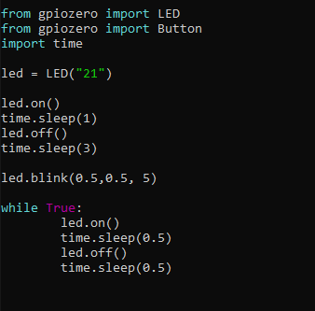

This is a simple piece of code that will turn an LED on and off repeatedly (some might say blinking), this is mostly a refresher from last semester as we did something similar. However, the library gpiozero is something I have not used before, so this helped familiarize me with the syntax. I did run into one question that I cannot figure out, if I have the while loop like I do in the code above, the code will completely skip over the led.blink line, but if I remove the while loop and its contents then the led.blink line will run as expected. I cannot figure out why this happens but either way the LED blinks.

Part 2:

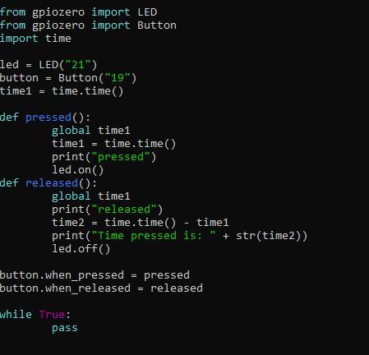

This code will turn on an LED when a button is pressed and turn it off when the button is released. It will also print to the console a message on both the pressed and released events. Finally, it will record how much time the button was pressed for and print it when the button is released. If given more time I would set it up so that it would print the current time (i.e. 9:34 am) when pressed and the updated time when released. I ran into some difficulty getting it to properly update the time using time.time(), however I solved this issue by referencing the variable time1 globally in each function (global time1).

Part 3:

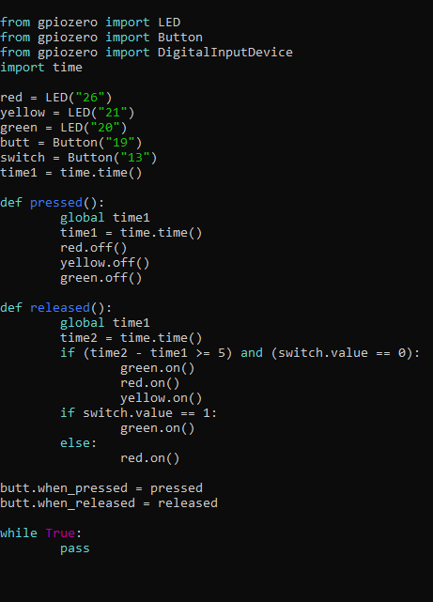

In this code I have added a slide switch and used some digital logic to make three LEDs turn on under different conditions. Using the same methods that I discovered in the previous parts of this lab, I made it so that if the switch is on and the button is released then the green LED turns on, and if the switch is off the red LED turns on instead, and if the button is held for 5 or more seconds, then released, all three LEDs turn on. I originally wanted to do this the opposite way, when pressed they would turn on and when released they would turn off however I could not get it to work that way and so this is the way I have done it. It was difficult to set up the slide switch, I originally tried to set it up using the DigitalInputDevice object from gpiozero however I could not get that to recognize the switch, instead I just told the program it was button and it worked, however I am wondering if this is the proper way to do it or if there is a better way.

Youtube link for the video: <https://youtu.be/A6sibgB_NKw>